Getting Started

Installation
The first step is to install MAQS. Checkout the MAQS Installation guide.
Optional installs are NUnit and StyleCop.

Creating Your First Solution

Building Your First Project
After the MAQS Visual Studio Extension and NuGet package have been installed, you are ready to start testing.
- Go To File > New > Project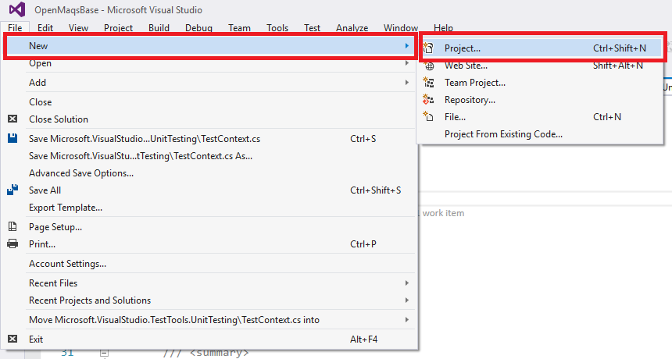

- Under Templates (in the side panel)
- Magenic's Open Test

There are two options, MAQS Framework - Selenium, that will start a project with tests run in VSTest, or MAQS Framework - NUnit - Selenium.
The only difference is the test adapter used with the included test templates.
Finally name the solution whatever you would like to name, and click "ok".

Adding a Page Model
To add a new Page Model from a template
- Right click PageModel project.
- Click Add ? New Item. This will open a list of templates.
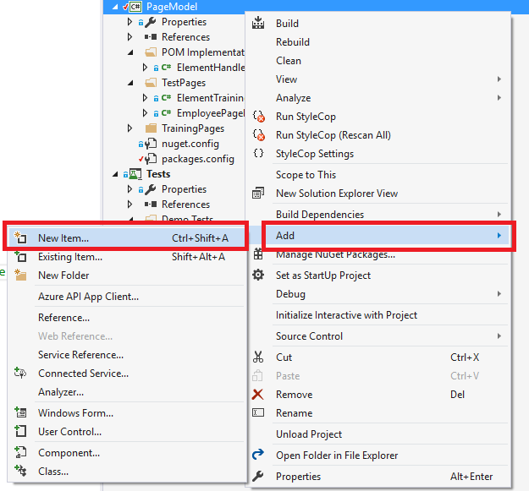
- Under Magenic's Open Test select the "MAQS Selenium Page Model Class"
- Choose a name
- Click the "Add" Button

This will add a template for a Page Object Model. The template is filled with sample code and methods. The methods included are common methods used on every page.

Adding a Test

VSTest Test
- Right click PageModel project.
- Click Add ? New Item. This will open a list of templates. 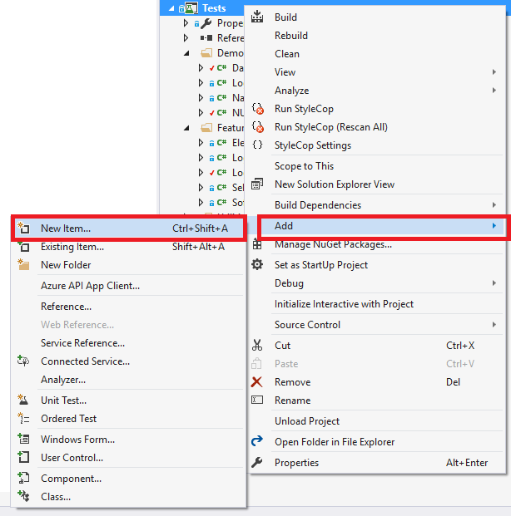
- Under Magenic's Open Test select the "MAQS Selenium VS Test Class"
- Choose a name
- Click the "Add" Button
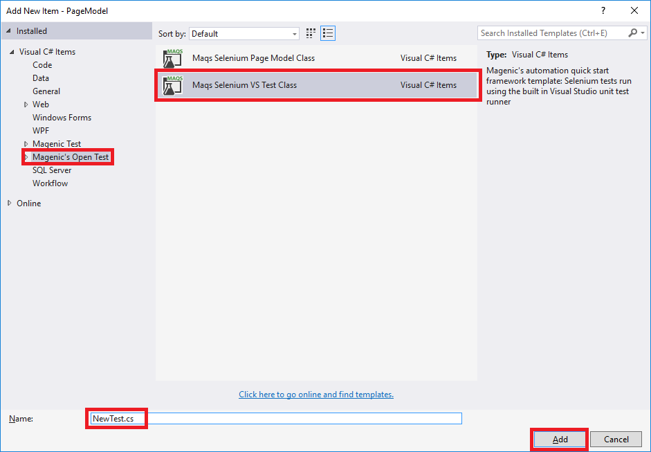
The VSTest class will generate a template for a VSTest TestClass and include a sample VSTest TestMethod. When run this will use the VSTest test runner to execute tests.

NUnit Test
- Right click PageModel project.
- Click Add ? New Item. This will open a list of templates.
- Expand the Magenic's Open Test and select the NUnit Only
- Select Maqs Selenium NUnit Test Class
- Choose a name
- Click the "Add" Button
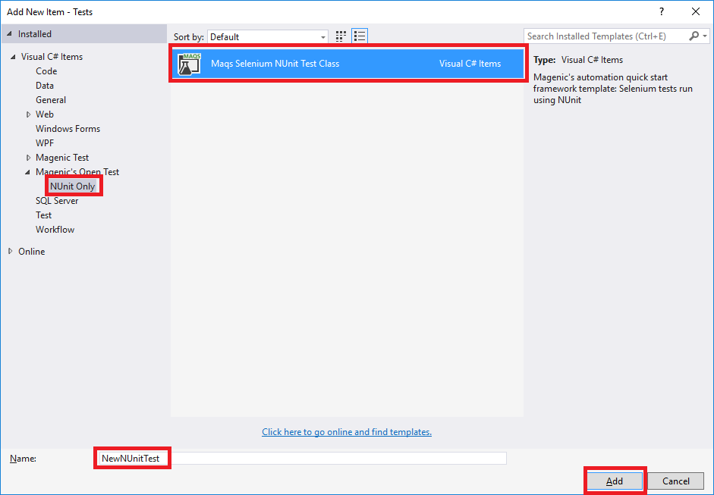
This will generate a template for the NUnit TestFixture with a sample NUnit Test.

Running Tests
Tests can be run through the command line using MSTest or NUnit, or through Visual Studio using the test explorer.

Enable Test Explorer
To enable the Test Explorer window
- Go to Test in the main menu bar
- Go to Windows in Test
- Click Text Explorer in Test

Running Tests from Test Explorer
Tests can be run singularly by right clicking a test and either clicking "Debug Selected Tests" to run in debug mode or clicking "Run Selected Tests" to run the tests normally.

Organizing Tests
Tests can be organized to more easily filter through what could potentially be a test solution with thousands of tests. There are two ways to change the grouping:
Right-click inside the Test Explorer window and select Group By.
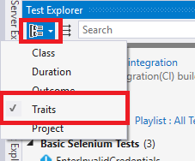
Left-click the Group by button in the top left corner off the Test Explorer, to the left of the Search field.
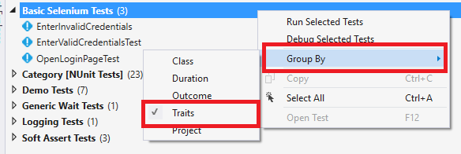

Adding Traits to tests
An easy way to group tests is to give those tests a trait attribute. These are written in the test classes.

VSTest Traits
Above the test method, either before or after the TestMethod attribute, add another attribute with the TestCategory tag.
Written As
[TestCategory(string testCategoryName)]
Examples
[TestCategory("Smoke Tests")]
string testCategory = "Login Tests" [TestCategory(testCategory)]
Test methods with multiple TestCategory attributes will add that test case to each attribute group, but the test will only run once when running all tests.

NUnit Traits
Above the test method, either before or after the Test attribute, add another attribute with the Category tag.
Written As
[Category(string testCategoryName)]
Examples
[Category("Smoke Tests")]
string testCategory = "Login Tests" [Category(testCategory)]
Test methods with multiple Category attributes will add that test case to each attribute group, but the test will only be run once when running all tests.

Configurations
There are a number of configurations included with MAQS. Checkout the MAQS Configurations guide.

Notes
- NEVER commit the NuGet packages folder
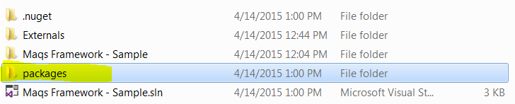
*You will break your build if you commit this folder and its content
- If you update the Nuget version of the Chrome, IE or PhantomJS web driver you will need to update your post build event to copy the new web driver to your build directory
